ICT ACADEMY OF KERALA
Summer Internship Report

Cyber Security



Team Members:
Abiya George
Bevis Mathew Thomas
Edwin K Mathew

Mar Baselios College of Engineering and Technology

CONTENT
Executive Summary………………………………………….3
Introduction……………………………………………………3
Objective……………………………………………………….3
Requirements…………………………………………………4
Report………………………………………………………… 4
Phase1: Introduction, Setup, and Enumeration….4
Phase2: Vulnerability Assessment…………………6
Phase3: Exploitation and Post-Exploitation……..11
Result and Finding………………………………………….14
Conclusion……………………………………………………14
APPENDIX…………………………………………………….14

EXECUTIVE SUMMARY
This project focused on assessing the security posture of the Kioptrix-1 virtual machine, a deliberately vulnerable system designed to mimic real-world environments. The primary objective was to gain root access by identifying and exploiting system vulnerabilities. The process involved a systematic application of cybersecurity techniques, including reconnaissance, scanning, enumeration, vulnerability assessment, exploitation, and post-exploitation.
By navigating these structured steps, the project demonstrated practical expertise in vulnerability identification and exploitation, providing insights into the lifecycle of a cyberattack. The exercise highlighted the importance of a comprehensive approach to system security and underscored critical areas where defensive strategies can mitigate risks. Successfully breaching the system and capturing the root flag underscored the relevance of hands-on learning in understanding and countering potential cyber threats. This summary encapsulates the technical and strategic lessons learned throughout the project.

INTRODUCTION
This project involved assessing a deliberately vulnerable virtual machine, Kioptrix-1, designed to simulate real-world security challenges. The objective was to identify and exploit system vulnerabilities to gain root access. The process required applying core cybersecurity techniques, including reconnaissance, scanning, vulnerability assessment, and exploitation. This hands-on exercise provided valuable insights into system weaknesses and the strategies attackers might use to exploit them.

Objective
This project involved assessing a deliberately vulnerable virtual machine, Kioptrix-1, designed to simulate real-world security challenges
Core cybersecurity techniques were applied, including:
- Reconnaissance
- Scanning
- Vulnerability assessment
- Exploitation
The hands-on approach provided practical insights into system vulnerabilities and potential attack strategies.

Requirements
Virtual Environment Setup:
  - A host system capable of running virtualization software (e.g., VMware or VirtualBox).
  - Download and configure the Kioptrix-1 VM.
Networking Configuration:
  - Proper network setup to ensure the VM is accessible for scanning and exploitation (e.g., bridged or host-only network mode).
Penetration Testing Tools:
  - Tools for reconnaissance and scanning (e.g., Nmap, Netcat).
  - Vulnerability assessment tools (e.g., Nessus, Nikto).
  - Exploitation frameworks (e.g., Metasploit Framework).
Secure System:
  - A dedicated and isolated environment to perform testing to prevent unintended network exposure.

Report
Phase 1: Introduction, Setup, and Enumeration
In the first phase of the project, the objective was to set up both the Kioptrix-1 virtual machine (VM) and Kali Linux, followed by performing reconnaissance to discover the Kioptrix-1 IP address and conducting initial scanning and enumeration.

Virtual Machine Setup
Both VMs, Kioptrix-1 and Kali Linux, were successfully configured and networked using VirtualBox. The network was set to bridged mode, ensuring both VMs could communicate over the same local network. After configuring the networking, the IP address of Kali Linux was determined using the command ifconfig eth0, which provided the local IP address of the attacking machine.

Reconnaissance and IP Discovery
To discover the IP address of the Kioptrix-1 VM, a network scan was initiated from Kali Linux using the nmap -sn command. This command performs a ping scan across the entire subnet, helping identify active hosts within the range. The subnet was determined based on the IP address and subnet mask of Kali Linux. After executing the scan, the Kioptrix-1 VM was successfully detected, revealing its IP address. This step demonstrated the ability to identify live hosts on the network, an essential component of the reconnaissance phase.

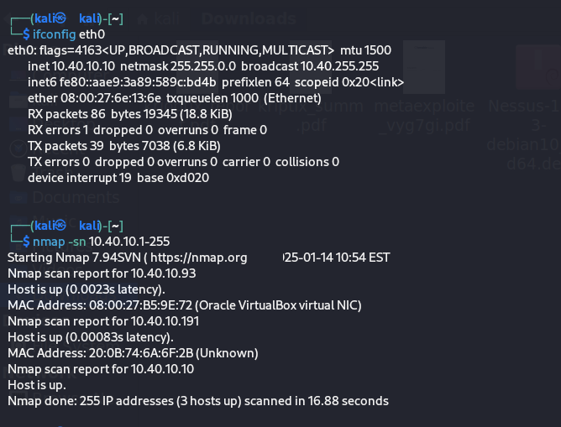

Initial Scanning and Enumeration
Once the IP address of Kioptrix-1 was identified, further scanning was conducted using Nmap to enumerate open ports and identify active services. The scan revealed several open ports, including commonly exploited services like SSH (port 22) and HTTP (port 80), along with some potential vulnerabilities that could be explored further. These findings provided valuable information for the next phases of the penetration testing process.
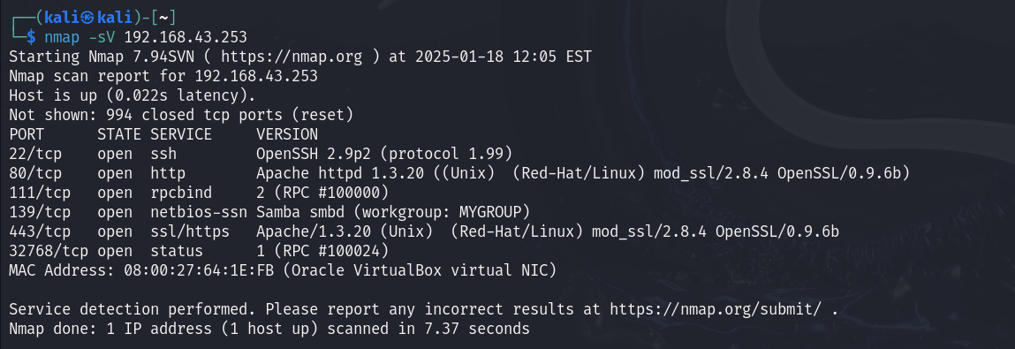
Phase 2: Vulnerability Assessment
In this phase, a thorough vulnerability assessment was performed on the identified services and open ports discovered during Phase 1 using advanced tools such as Nmap, Nikto, Nessus, and OpenVAS. The goal was to identify potential exploitable weaknesses in the system to guide the next steps in the penetration testing process
1.A detailed Nmap scan identified several open ports and their associated services:
- Port 22 (SSH): An older version of OpenSSH was detected, potentially vulnerable to brute-force attacks and known exploits.
- Port 80 (HTTP): Apache HTTP server was identified, running an outdated version with vulnerabilities related to directory traversal and remote code execution.
- Port 139 (Samba): Samba services were found running on these ports, indicating potential vulnerabilities such as weak SMB configurations, improper file-sharing permissions, or susceptibility to exploits like EternalBlue.
- Port 21 (FTP): FTP service was open, and version detection revealed it lacked secure configurations, making it vulnerable to plain-text credential interception.
- Port 3306 (MySQL): The MySQL database service was active, but weak authentication mechanisms could allow unauthorized access.
. 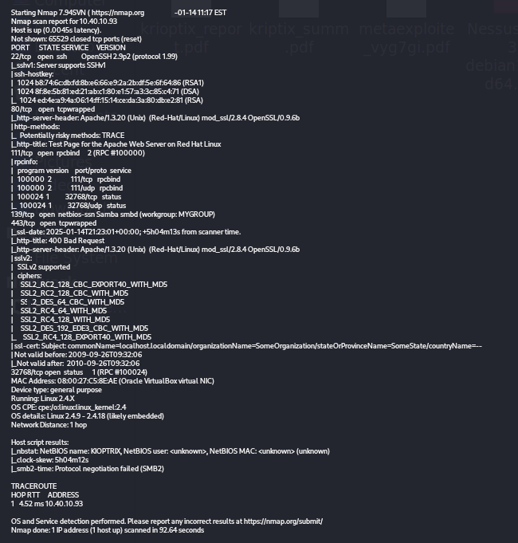
2. Nikto focused on assessing the HTTP service (port 80). Key findings included:
- Outdated Apache Version: The server was running an older version of Apache, flagged for known vulnerabilities like buffer overflows and path traversal exploits.
- Potentially Dangerous HTTP Methods: Methods such as TRACE and DELETE were enabled, which could be exploited for unauthorized interaction with the server.
- Default or Exposed Directories: Nikto detected default directories and files, which could provide sensitive information to attackers
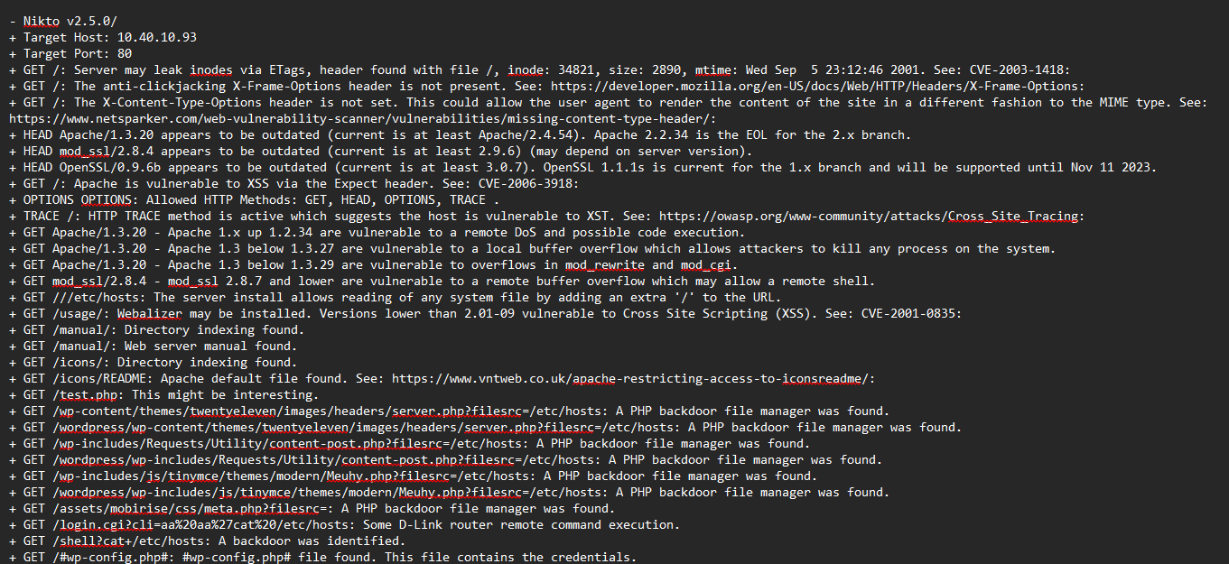
3.Nessus provided an extensive vulnerability assessment across all identified services:
- Samba Vulnerabilities: Weak configurations in the Samba service were flagged, including the possibility of anonymous login or access to shared files. Known vulnerabilities like CVE-2007-2447 (Samba remote code execution) were listed as high-risk.
- Unpatched Software: Multiple unpatched vulnerabilities were detected in Apache, Samba, and OpenSSH, increasing the likelihood of remote exploitation.
- Weak Authentication: The FTP and MySQL services were found to use weak or default authentication methods, making them susceptible to brute-force or credential-stealing attacks.

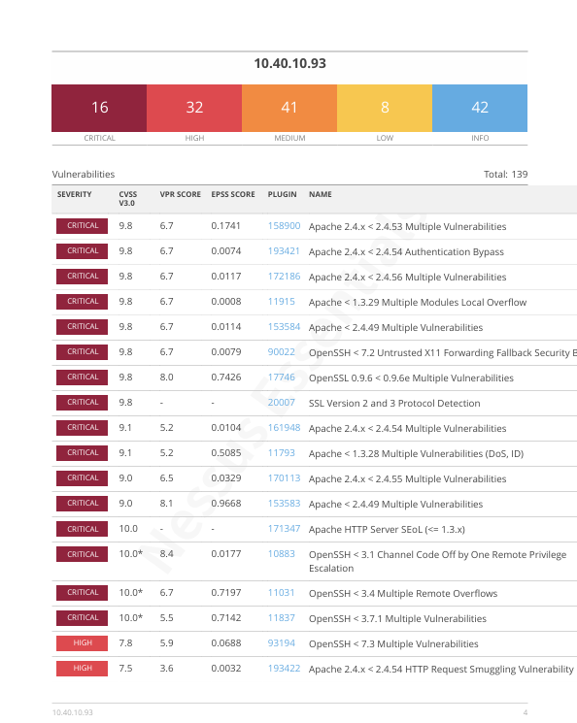
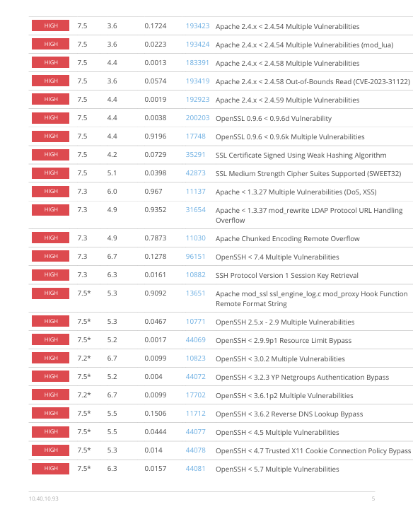
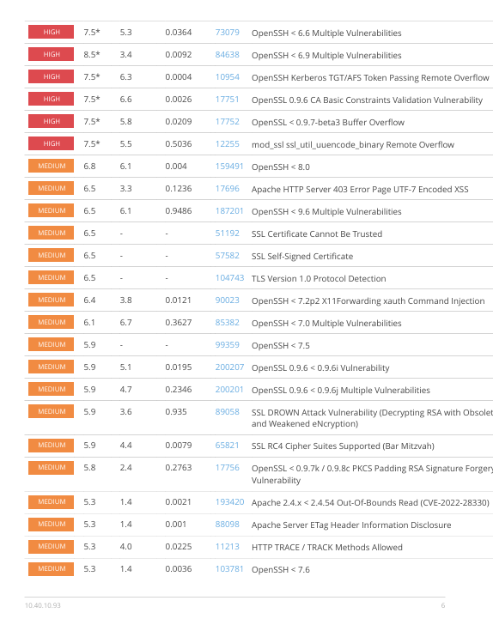
Phase 3: Exploitation and Post-Exploitation
The report indicates that the primary vulnerabilities in Kioptrix are associated with OpenSSH, Apache, and Samba. Since the vulnerable versions of OpenSSH and Apache running on Kioptrix have already been identified, the next step is to determine the specific version of Samba present on the system. This information will help assess potential security risks and identify relevant exploits.
For finding version of Samba we can use Metasploit framework.

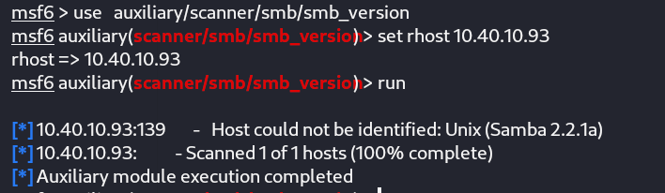

In this step, the SMB version scanner from the auxiliary module was utilized. The target IP address of the Kioptrix system was set as the RHOST, and the scanner was executed to identify the specific version of Samba running on the system.

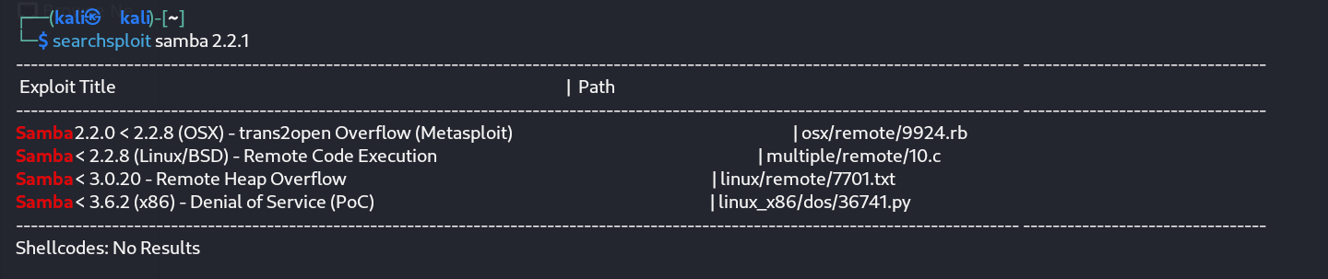

The identified version of Samba is vulnerable to the Trans2open exploit, which can provide root access when successfully executed. Upon comparison with other vulnerabilities, Trans2open is deemed more reliable and offers a relatively straightforward path to obtaining root access. Therefore, the decision was made to proceed with exploiting the Trans2open vulnerability.

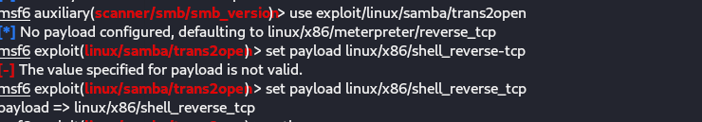
The samba/trans2open exploit module was utilized for this step, with the /shell_reverse_tcp payload configured. After setting the necessary parameters, the exploit was executed to target the vulnerable Samba service

.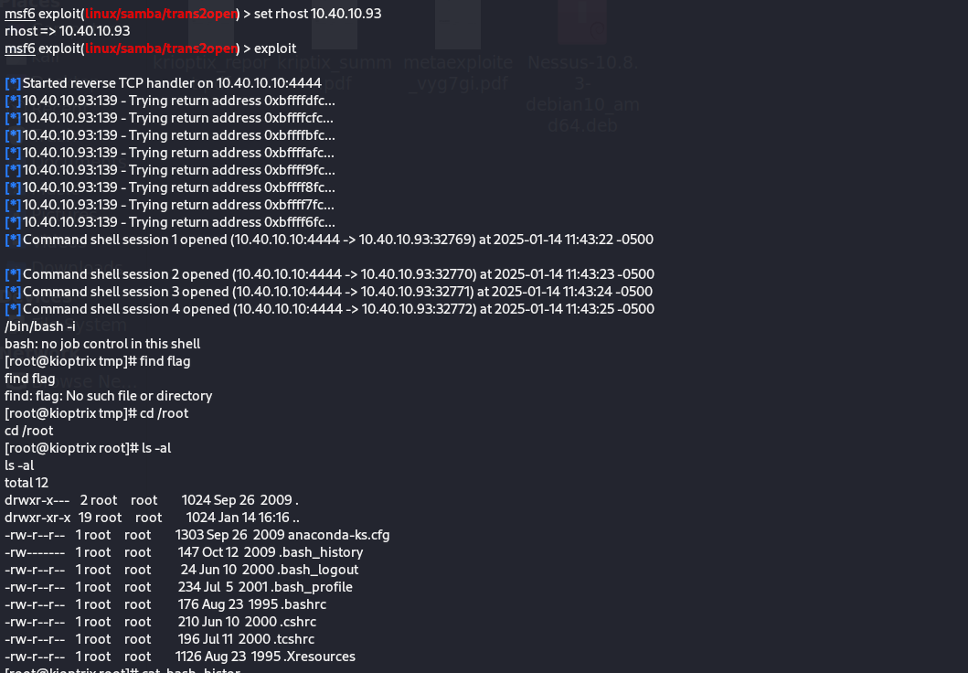

The execution of the exploit successfully granted root access to the system. Upon exploring the files in the root directory, the .bash_history file was examined, revealing a command named mail. Running this command displayed an entry titled “About Kioptrix 2”. Upon selecting it, the flag was successfully retrieved.

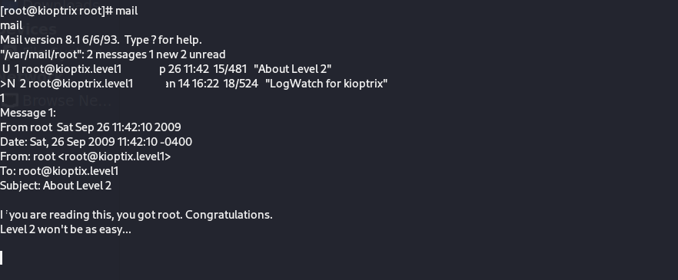
Post-Exploitation
Upon examining the /etc/passwd file, several inactive user accounts were identified. One of these accounts can potentially be utilized for subsequent login attempts during the exploitation process.
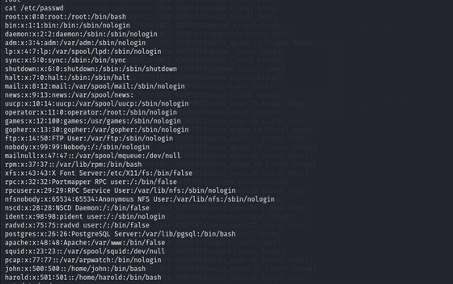

The user account gopher was selected for further actions. The password for this account was modified, and its default terminal was updated to facilitate subsequent access and operations.

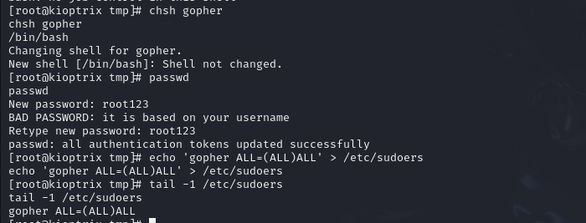
With the changes applied, it is now possible to securely log in to the system via SSH using the gopher account at any time.

RESULTS & FINDINGS
The project successfully identified and exploited vulnerabilities in the Kioptrix-1 virtual machine, demonstrating practical expertise in penetration testing. Key findings included insecure configurations in services like SSH, Apache, and Samba, leading to root access. The exercise reinforced the importance of robust security practices and proactive vulnerability management.

Conclusion
This project offered a practical exploration of system vulnerabilities using Kioptrix-1, a deliberately insecure virtual machine. Through reconnaissance, vulnerability assessment, exploitation, and post-exploitation, the team successfully identified and exploited weaknesses to gain root access. Tools like Nmap, Nessus, Metasploit, and Nikto were effectively utilized, bridging theoretical knowledge with real-world application.

The exercise highlighted the importance of secure configurations, timely updates, and robust defenses in mitigating cyber risks. Challenges encountered emphasized the dynamic nature of cybersecurity and the need for adaptive techniques. Overall, this project enhanced our understanding of system security and the lifecycle of cyber threats.

APPENDIX
This section includes supplemental details such as configurations, commands, and tools used, including Nmap, Nessus, Metasploit, and Nikto, along with system logs and outputs from vulnerability assessments and exploitation phases.

